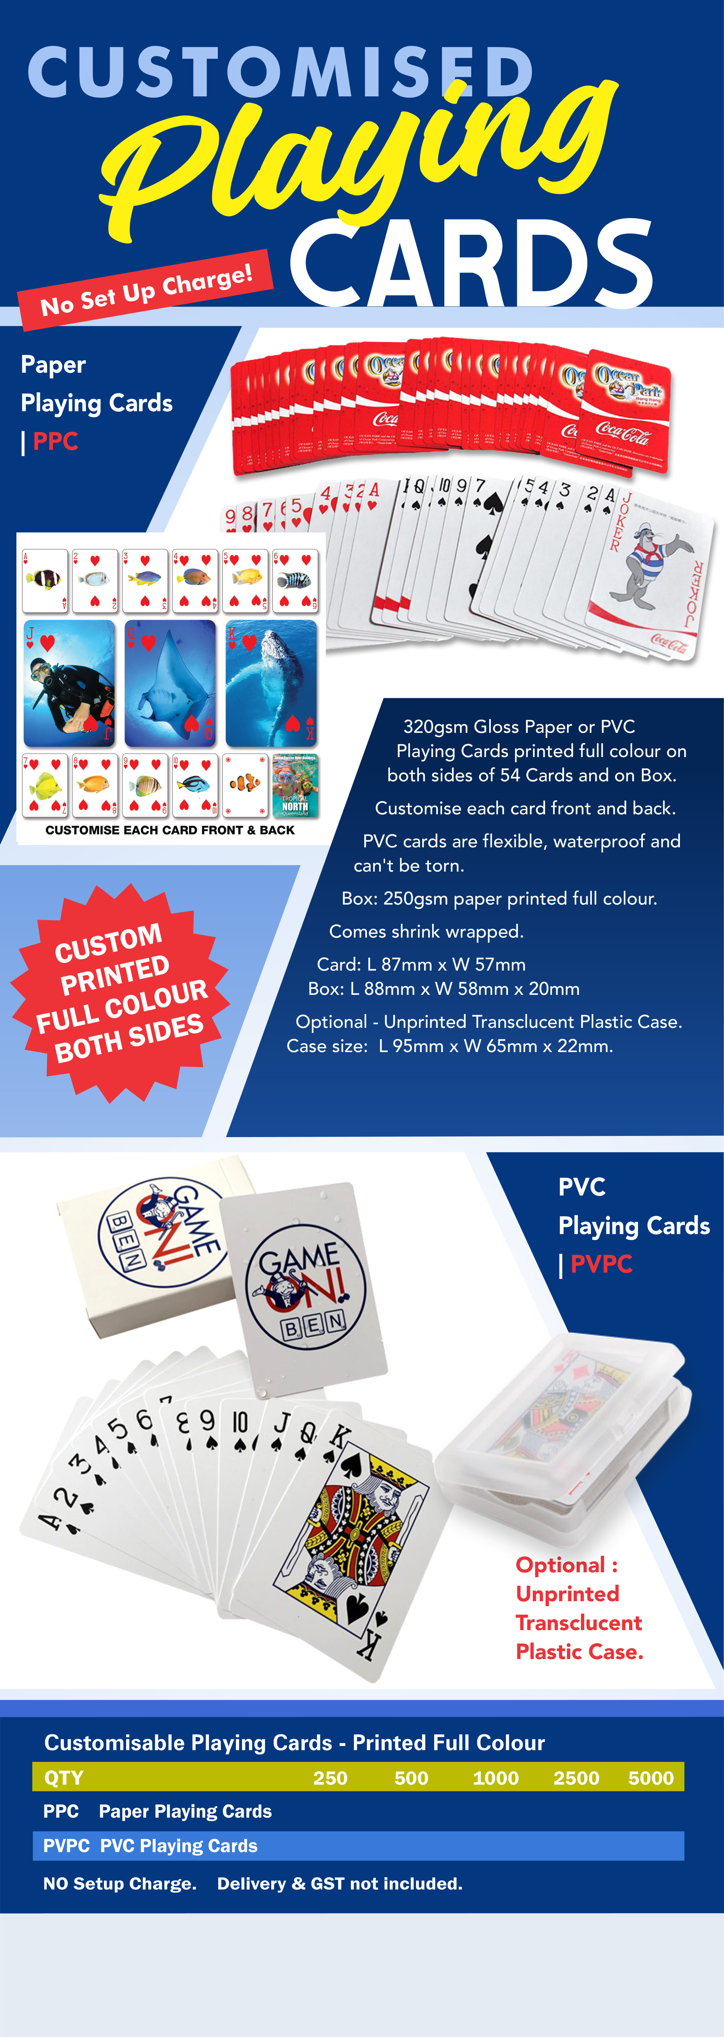

Insert your details here
Edit prices in pricebox

$0.00 $0.00 $0.00 $0.00 $0.00
$0.00 $0.00 $0.00 $0.00 $0.00

Insert your logo here

