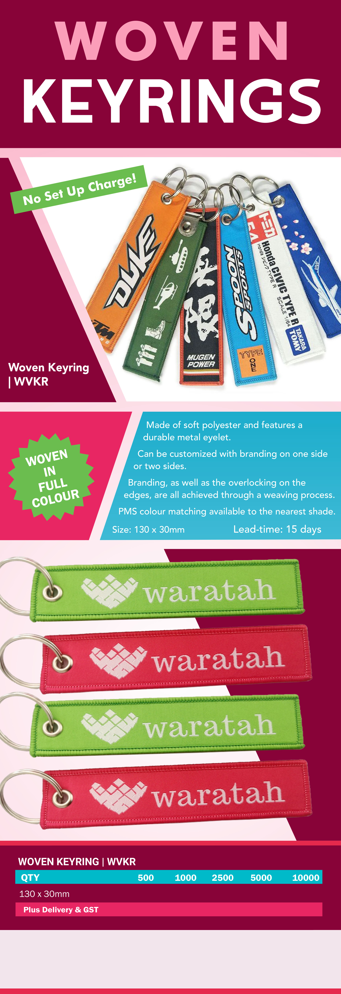
0.00 0.00 0.00 0.00 0.00

0.00

Your logo here

0.00

Your details here

0.00

